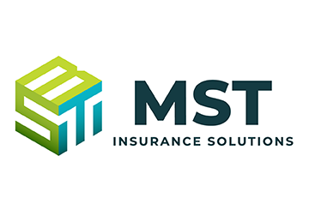
Aug. 16, 2022
The IRS released updated pay or play penalty amounts for 2023.
March 9, 2023
The IRS released updated pay or play penalty amounts for 2024.
2024 Calendar Year
The 2024 penalty amounts apply for failures to offer affordable, minimum value coverage during the 2024 calendar year.
ACA Pay or Play Penalties Will Increase for 2024
On March 9, 2023, the IRS released updated penalty amounts for 2024 related to the employer shared responsibility (pay or play) rules under the Affordable Care Act (ACA). For calendar year 2024, the adjusted $2,000 penalty amount is $2,970 and the adjusted $3,000 penalty amount is $4,460.
Pay or Play Penalty Calculations
Under the pay or play rules, an applicable large employer (ALE) is only liable for a penalty if at least one full-time employee receives a subsidy for Exchange coverage. Employees who are offered affordable, minimum value (MV) coverage are generally not eligible for these Exchange subsidies.
Depending on the circumstances, one of two penalties may apply under the pay or play rules—the 4980H(a) penalty or the 4980H(b) penalty.
- Under Section 4980H(a), an ALE will be subject to a penalty if it does not offer coverage to “substantially all” (generally, at least 95%) of its full-time employees (and dependents) and any one of its full-time employees receives a subsidy toward his or her Exchange plan. The monthly penalty assessed on ALEs that do not offer coverage to substantially all full-time employees and their dependents is equal to the ALE’s number of full-time employees (minus 30) multiplied by 1/12 of $2,000 (as adjusted), for any applicable month.

- Under Section 4980H(b), ALEs that offer coverage to substantially all full-time employees (and dependents) may still be subject to a penalty if at least one full-time employee obtains a subsidy through an Exchange because the ALE did not offer coverage to all full-time employees, or the ALE’s coverage is unaffordable or does not provide MV. The monthly penalty assessed on an ALE for each full-time employee who receives a subsidy is 1/12 of $3,000 (as adjusted) for any applicable month. However, the total penalty for an ALE is limited to the 4980H(a) penalty amount.
IRS Pay or Play Penalty Resources
The IRS provides a variety of resources on the pay or play provisions, which provide more information on calculating the penalty. Employers can use the following two IRS webpages for more details:
- Employer Shared Responsibility Provisions
- Types of Employer Payments and How They Are Calculated

Additional webpages are dedicated to other aspects of the pay or play rules.

